Scenario 8: VPC Peering with Another AWS Account
scenario, we will create a VPC Peering between:
- Your AWS Account (Account A)
- Another AWS Account (Account B)
The goal is to allow private communication between VPCs that belong to different AWS accounts.
This is commonly used when:
- Two teams use separate AWS accounts
- A client or partner wants to access your VPC privately
- You need to share internal services between accounts
Its same process of the above one but instead of selecting my account you need to select another account and give that account ID and accept the invite.
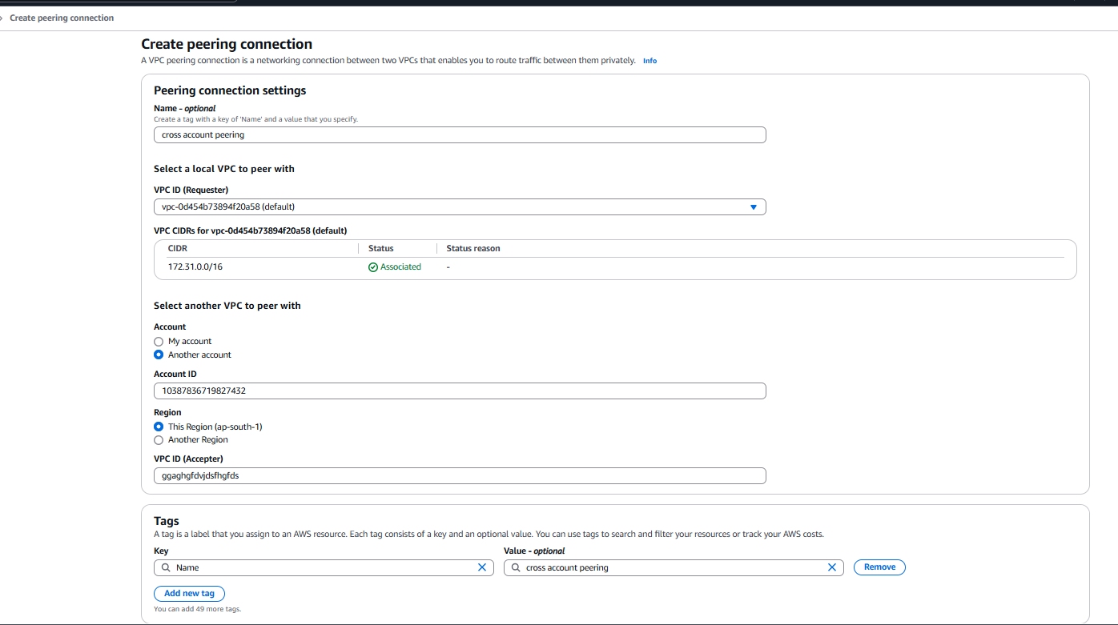

Step | Description
1 | Create peering in Account A
2 | Accept peering in Account B
3 | Update route tables in both VPCs
4 | Update security groups in both accounts
5 | Validate private connectivity

